OKLAHOMA BUSINESS ETHICS CONSORTIUM
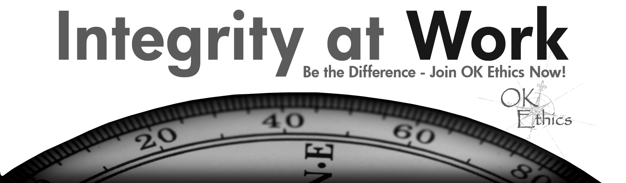
Oklahoma City Chapter ~ November 14, 2007

- KUDOS Bob Byrne, Ethics Advisor for Boeing, President of OkEthics Foundation
Guiding Principle: HONOR We express gratefulness to our hosts, sponsors and speakers.
"Gratitude can transform common days into thanksgivings, turn routine jobs into joy, and change ordinary opportunities into blessings." ~William Arthur Ward~
  - Joshua Jantz for his dependability in preparing and organizing our name tags every month. Also, we are grateful to him for organizing this month’s meeting at the Character First Institute and accommodating all the special requests.
  - Greg Byers – Sinclair Broadcasting Group – As Registration Chair, Greg unselfishly shares his time with others (Tulsa chapter) and is consistently conscientious in helping OkEthics members and guests.
  - Mary Kay Huggard & the Principal Technologies team for their dedication & availability in handling the registrations!
  - Connie Barwick – Maximum Multi Media Creations for the pre-meeting Power Point presentations, bookkeeping and website expertise. We especially appreciate Connie for taking a week’s vacation from her regular job to help OkEthics – including a trip to assist the Tulsa chapter this week.
  - Blaine Rider, now in the real estate business while maintaining his connections with Digital West, has agreed to provide photos of our meetings for our new online photo gallery. Many thanks to him for the recent updated Board photos.
  - Tess Smith with Walker Companies for cleaning and storing our new banner – then magically making it reappear each month.
  - Andrew Ranson of Giant Partners for arranging today’s meeting featuring Scott Pruitt.
  - Welcome Oklahoma City University students!
  - Behind the scenes, our dedicated volunteers who serve on the Board and keep the organization running!

II. BOARD HONORS Shannon Warren, Founder & Acting Director (Volunteer), OkEthics
See special attachment for complete list of Board members being honored in OKC today.

- Special thanks to Mike Rives, Benchmark Monuments of Tulsa, for the marble coasters that he provided.
- Roger Mashore, CEO of Midwest Trophy, for use of his music in the Board tribute – and for expediting our member awards..
- Blaine Rider (Realtor) for making time to prepare the video honoring our Board members.

- MEMBERSHIP HONORS

NAVIGATOR –
Member honors presented by Bob Byrne, OkEthics Foundation President to the following companies:

Devon Energy, Nextep, SandRidge Energy & The Bama Companies

The Navigator membership of $7500 allows for 16 prepaid members for all OkEthics events.
Shows support by allowing OkEthics to post logo on Home page of website and promotional materials.

OKLAHOMA STAR -
Member honors presented by Janice Dobbs, Devon Energy, OkEthics Foundation Board of Directors

Chesapeake Energy, Express Personnel Services, Enterprise Rent-A-Car,
Kimray, Inc., & Principal Technologies

The Oklahoma Star membership of $5000 Includes 8 memberships; prepaid for all OkEthics events.
Shows support by allowing OkEthics to post logo on Home page of website and promotional materials.

HORIZON MEMBERS
Member honors presented by Shannon Warren, OkEthics Founder

Dollar Thrifty Automotive Group (Tulsa), Norris (Tulsa), The Rowland Group (Tulsa)
Metro Technology Center and Valir Health

The Horizon Member demonstrates support through 8 prepaid memberships per year.

LEADING MEMBERS
Member honors presented by Bob Byrne, OkEthics Foundation President
OKC: Accel Financial Staffing Solutions, BKD, LLP; Gabbard & Company; McAfee & Taft,
OBU International Graduate School
Tulsa: Cherokee Nation Enterprises; Hogan Assessment Systems; KPMG; SpiritBank; Tulsa Technology Center
The Leading Member demonstrates support through 2 prepaid memberships per year.
NOTE: Members of the Oklahoma Business Ethics Consortium frequently share information concerning various issues and developments that may have legal implications. The discussions, commentary, and handouts at Consortium meetings or presentations to other organizations are for general informational purposes only. They cover only some aspects of the subject topic, and do not constitute a complete legal analysis of the topic or how it might apply to any particular set of facts. Before taking any action based on information presented by a Consortium member, participants are encouraged to consult a qualified attorney. The observations and comments of presenters at Consortium meetings and networking are the views and opinions of the presenter and do not constitute the opinion or policies of the Consortium or any of its members. Presenters are respectfully requested to avoid profanity, preaching, politics and self-promotion during their lectures.

- CHARACTER PRESENTATION -
Tom Hill, CEO of Kimray, Inc. &
Founder of the Character First Institute

- SPEAKER INTRODUCTION:
Andrew Ranson of Giant Partners

- KEYNOTE SPEAKER:
Scott Pruitt, Managing Partner, Oklahoma RedHawks,
“The Business of Sports”

VII. UPCOMING EVENTS Shannon Warren, OkEthics Founder & Acting Director
Advance reservations required for all events ~
Visit our website at www.okethics.org or call 858-2233;
Member discounts apply regardless of location.
OKC Chapter
- December 12 – 11:30 to 1:00; Petroleum Club

*** RECOMMENDED FOR 1 CPE CREDIT****

“How Good Organizations Turn Evil: A study in behavior”
Ever said, "What were they thinking?" or "I'd never do that"? Sometimes we are astonished at the behavior of organizations and their leaders. But, the truth is that could happen to us, too. In the dynamics of rapid organizational change, we may find ourselves morphing in situations that don't bring out our best.
Discussion Highlights: Moderated by Dr. James Branscum, MetroTech
- Defining "evil" in organizations
(Dr. Danene Vincent, Metro Tech & Dr. Cappy Leland, Performance Dashboard, Inc.
- Individual “Contaminants” - Power, pressures and justice
(Dr. Eric Day, University of Oklahoma)
- Organizational “Toxins” & Bottom Line Impact
(Dr. Howard Stein, OU Health Sciences)
- Assessing Cultural Risks in Organizations
(Joe Evans, CFO, Chaparral Energy)
- Guideposts for Heroic Ethical Decision-Making

- January 8, 2008 - Lindy Ritz, Director of the Mike Moroney Aeronautical Center (FAA)

- March 12, 2008 – “Religion’s Impact on Ethical Decision-Making in the Workplace”
Panel of clerics lead by moderator, Dr. Vince Orza, Dean of Meinders School of Business, OCU; confirmed Dr. Bob Long from St. Luke’s Methodist Church; Rabbi Russell Fox of Emmanuel Synagogue and Dr. Imad Enchassi of the Islamic Society of Greater Oklahoma City.

Volunteers needed to assist with PR (bulletins) and facilities for up to 500 attendees.

Tulsa Chapter
- November 15 – Dr. Gene Callahan, Superintendent of Tulsa Technology Center

VIII. OTHER RELATED PROGRAMS:

Character First Institute -

Oklahoma City Business and Community Leaders' Breakfast and Luncheon
Would you like to enhance morale, strengthen coworker relationships, create a positive learning environment, and lead with integrity? Join us at the monthly Business and Community Leaders' Breakfast and Luncheon.

Topic: Thriftiness in the Workplace

Registration Information: Call 815-0001, or visit www.characterok.org
Dates: Luncheon; Thursday, November 29, 2007—12 P.M. to 1 P.M.
Cost: $10
Oklahoma Christian University – School of Business Administration,
OC Accounting Club
Speaker: Sherron Watkins, Enron Whistleblower; “Moral Courage”
Date: December 7; 7:30 p.m.
Where: OC Campus, Hardeman Auditorium (in Garvey Center) 2501 East Memorial Road
Registration: www.oc.edu or contact Elaine.Kelly@oc.edu
PLEASE HELP US CONTROL COSTS BY LEAVING YOUR NAME TAG HERE!___
Oklahoma Business Ethics Consortium
Guiding Principles
Adopted July, 2004; Revised September 2004

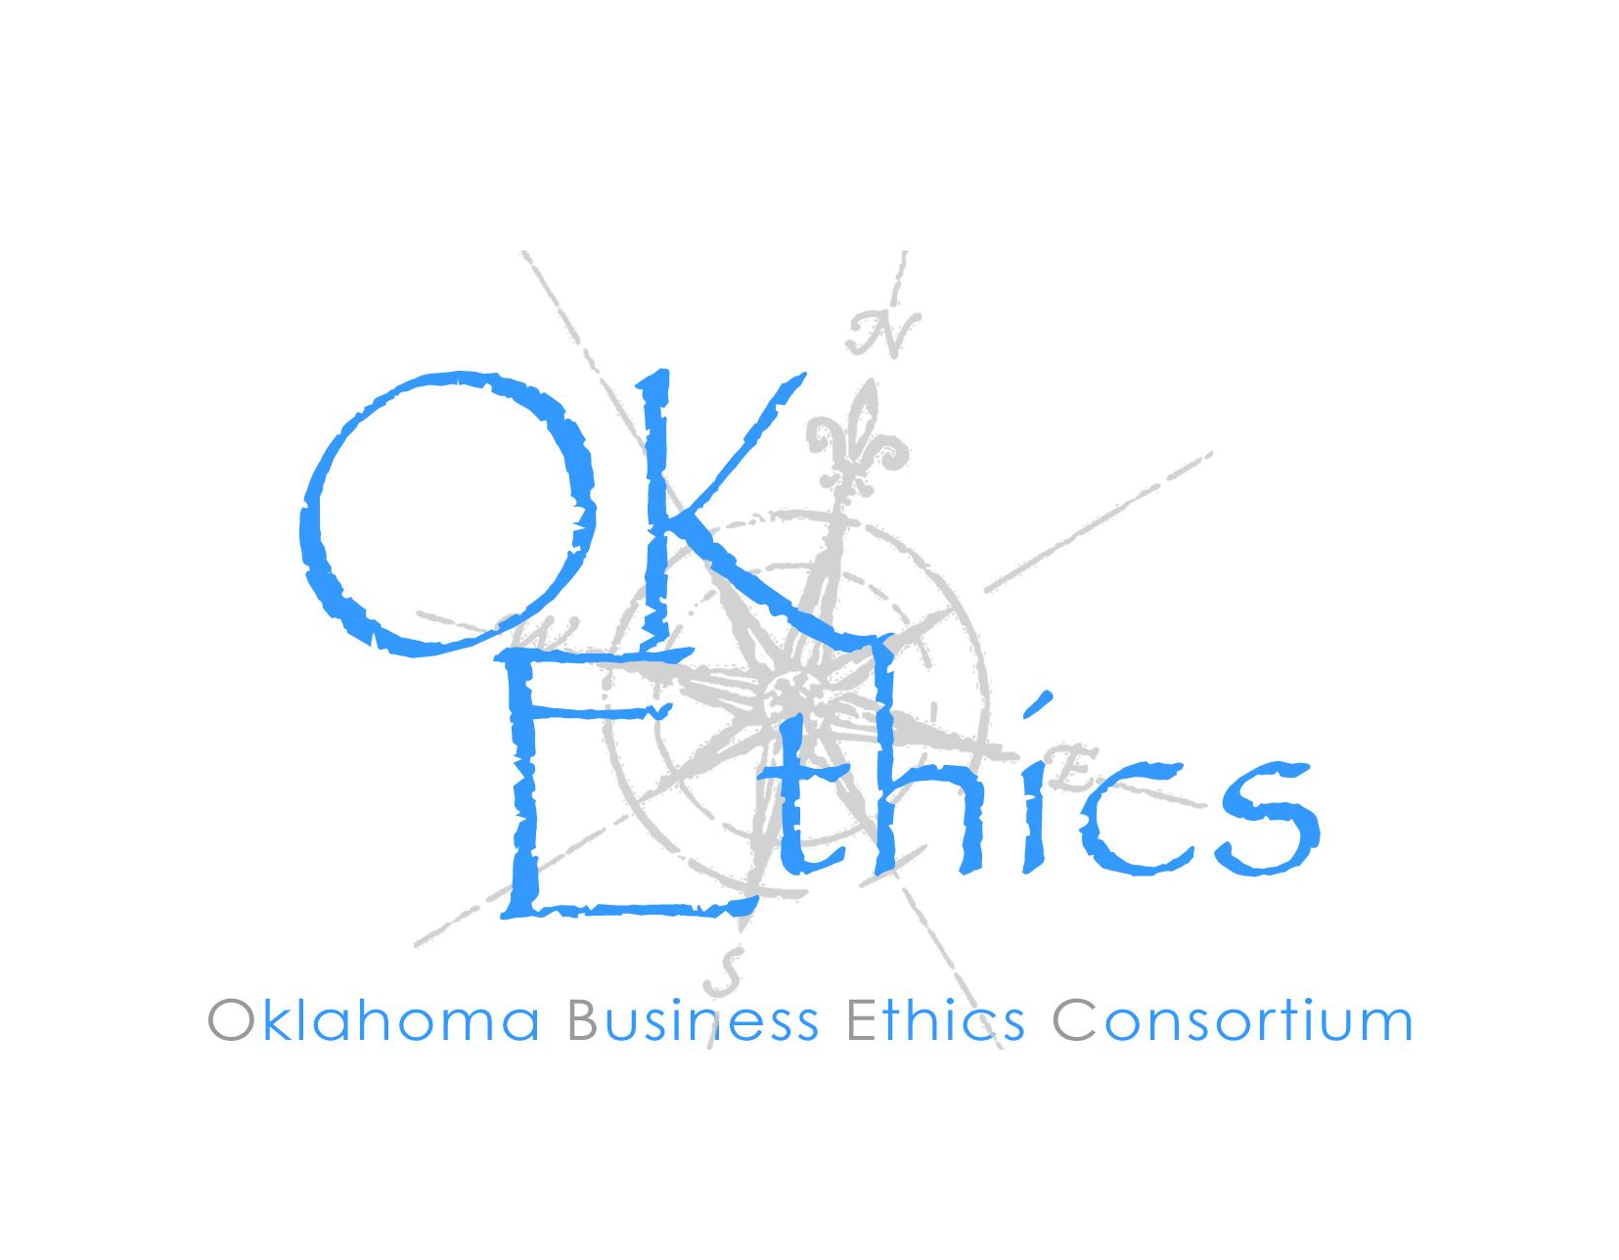
To ensure that the Consortium fosters positive characteristics of integrity in the successful achievement of its goals, these Guiding Principles were discussed and adopted (with revisions) during a milestone planning session held by Consortium leaders in Stroud on June 18, 2004. These are heavily guided by the Character First Institute’s values and philosophies.

I. Responsibility to Self and Others:
- Service:
  - Passion for promoting ethics and integrity
  - Encouraging the promotion of ethical behavior through personal actions and
  - Sharing ideas and resources
  - Responsibility and accountability for fulfilling the mission of the Consortium.

- Collaboration:
  - Achievement of common goals through mutually beneficial relationships
    - Service to the Consortium over promotion of self-interest
    - Cooperation over competition in the context of the Consortium’s efforts
Members collaborate by being Constructively engaged in discussion and topics
    - Seeking consensus in interactive discussions

- Respect:
  - Members may become aware of confidential information shared by others in an effort to determine an ethical course of action. We ask members to be sensitive in recognizing and respecting the efforts made toward achieving ethical behavior. In that vein, public disclosure of this information is discouraged.
  - We respect other members and the process by:
    - Exhibiting listening skills and actively listening to discussions
    - Being open to other points of view and outcomes
    - We are an inclusive organization and demonstrate this by welcoming members who are in different stages of learning as applied to ethical behavior.

II. Lead with Integrity

- Dependability:
  - Members are asked to demonstrate their support of this initiative by consistently attending meetings.

- Initiative:
  - Recruiting other members who have demonstrated a desire to promote ethical behavior in their organizations.
  - Recognizing what needs to be done to help promote the Mission of the Consortium and taking action to assist in that effort.

- Honor:
  - Members are asked to honor the Consortium through the practice of integrity and ethical behavior in their business dealings.
  - We express gratefulness to our hosts, sponsors and speakers.
  - Realizing that each of us is in a mode of continual learning, we demonstrate humility, care and compassion when sharing our thoughts and knowledge.

- Courage:
  - Speak the truth with confidence and encourage others to do the same.

